**MLOps Group 24**

**Group Members**

* Rajneesh Jha (2022ac05706)
* Sri Jayant (2022ac05045)
* Abhilesh Subhashrao Jawanjal (2022ac05604)
* Jeny Jasmine (2022ac05467)
* Mulla Akib Javed (2022ac05631)

**M4: Model Deployment & Orchestration**

**Deployment on GCP**

URL : <https://my-ml-app-jbw5x6tq6a-uc.a.run.app>

gcloud auth configure-docker

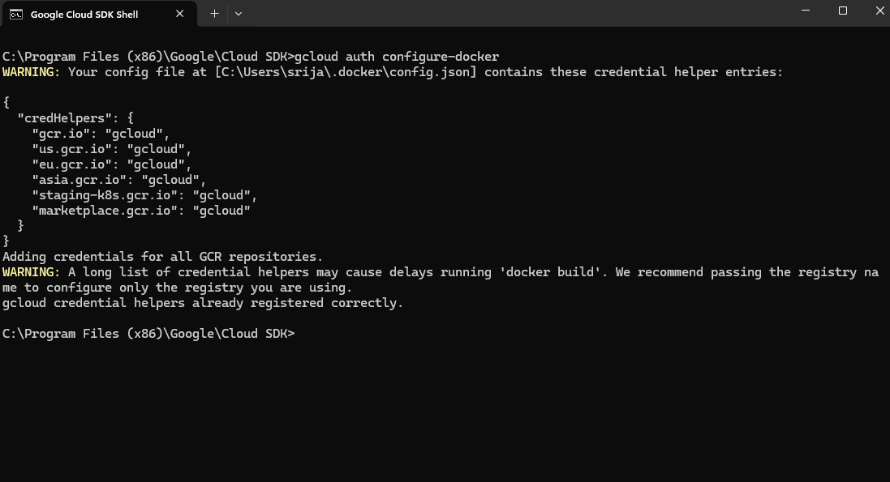

docker pull srijayantsingh/my-ml-app:latest

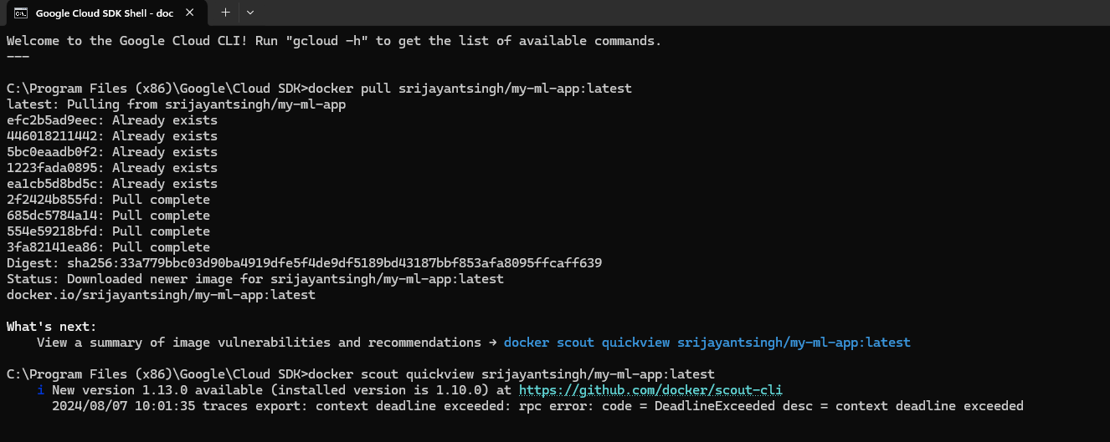

docker tag srijayantsingh/my-ml-app:latest gcr.io/mlops-assignment-1-431618/my-ml-app:latest

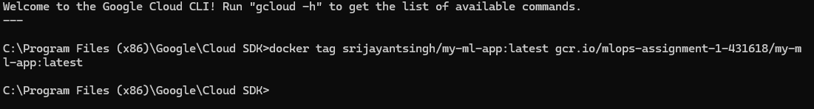

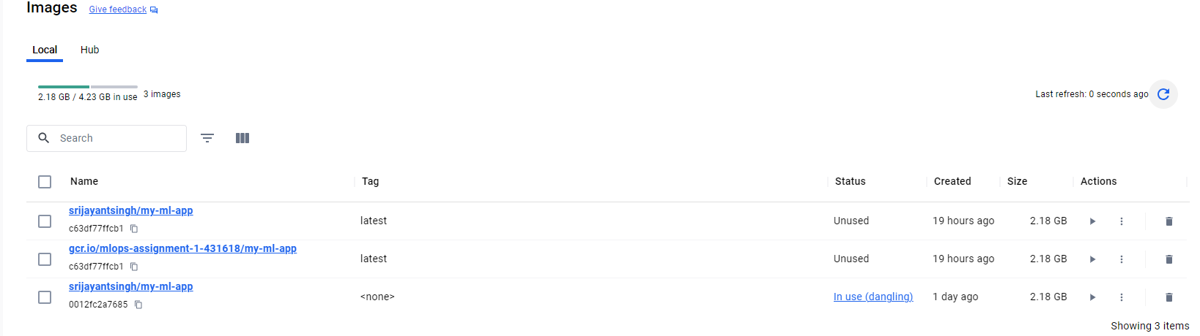

docker push gcr.io/mlops-assignment-1-431618/my-ml-app:latest

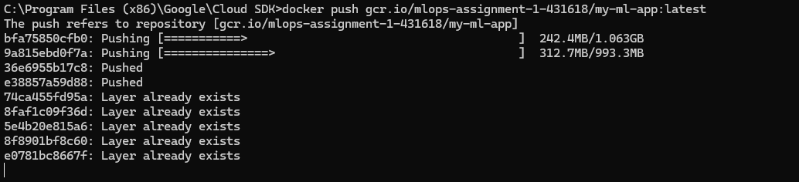

gcloud run deploy my-ml-app --image gcr.io/mlops-assignment-1-431618/my-ml-app:latest --platform managed --region us-central1 --allow-unauthenticated

